TECH SAKSHAM

Case Study Report

Data Analytics with Power BI

“360-DEGREE BUSINESS ANALYSIS OF ONLINE DELIVERY APP”

**GOVERNMENT ARTS COLLEGE FOR WOMEN,**

**KRISHNAGIRI-635001**.

|  |  |
| --- | --- |
| **NM ID** | **NAME** |
| **76BB59C7042CB7689B0488C53ADAC317** | **NIVETHA G** |

Trainer Name : R.UMAMAHESHWARI Master Trainer: R.UMAMAHESHWARI

**ABSTRACT**

In the fast-paced world of online delivery apps, harnessing the power of comprehensive business analytics has become imperative for sustained success and competitive edge. This abstract delves into the realm of 360-degree business analytics, offering a panoramic view of the intricate dynamics governing online delivery platforms. Through a multidimensional approach encompassing customer behavior analysis, operational efficiency evaluation, market trend identification, and strategic decision-making, this study elucidates the transformative potential of leveraging data-driven insights. By synthesizing data from diverse touch points including user interactions, delivery logistics, and market fluctuations, businesses can optimize resource allocation, enhance service quality, and tailor offerings to meet evolving consumer demands. Moreover, the integration of advanced technologies such as machine learning and predictive analytics empowers stakeholders to anticipate future trends, mitigate risks, and capitalize on emerging opportunities.

## INDEX

|  |  |  |
| --- | --- | --- |
| **S.No** | **Table of Contents** | **Page No.** |
| 1 | Chapter 1: Introduction | 4 |
| 2 | Chapter 2: Services and Tools Required | 10 |
| 3 | Chapter 3:Project Architecture | 17 |
| 4 | Chapter 4:Modelling and Result | 21 |
| 5 | Conclusion | 25 |
| 6 | Future Scope | 26 |
| 7 | References | 27 |
| 8 | Link | 28 |

#### CHAPTER 1 INTRODUCTION

* 1. **Problem Statement**

The problem statement for conducting a 360-degree business analytics assessment of an online delivery app involves identifying and addressing challenges across various aspects of the business, including customer acquisition and retention, operational efficiency, market analysis, competitor benchmarking, and technological advancements. This comprehensive analysis aims to identify areas for improvement, optimize resources, enhance customer experience, and maintain a competitive edge in the rapidly evolving online delivery industry.

#### Proposed Solution

Here are a few proposed solutions for enhancing online delivery apps:

1. **\*Improved User Interface*:** Streamline the app's interface to make it more intuitive and user-friendly, allowing customers to browse products and place orders effortlessly.
2. **\*Personalized Recommendations*:** Implement a recommendation engine based on user preferences, order history, and browsing behavior to suggest relevant items, increasing engagement and sales.
3. **\*Enhanced Tracking and Notifications*:** Provide real-time order tracking and status updates to keep customers informed about their delivery progress, reducing anxiety and improving satisfaction.
4. **\*Optimized Routing and Delivery Management*:** Utilize advanced algorithms to optimize delivery routes, minimize delivery times, and enhance efficiency for both customers and delivery personnel.
5. **\*Integrate Multiple Payment Options*:** Offer a variety of payment methods including credit/debit cards, digital wallets, and cash on delivery to cater to diverse customer preferences and increase convenience.
6. **\*Feedback Mechanism*:** Implement a feedback system to gather customer reviews and ratings, enabling continuous improvement of service quality and addressing any issues promptly.
7. **\*Social Media Integration*:** Allow users to share their shopping experiences and favorite products on social media platforms, facilitating word- of-mouth marketing and increasing brand visibility.
8. **\*Promotions and Loyalty Programs*:** Introduce special offers, discounts, and loyalty programs to incentivize repeat purchases and foster customer loyalty.
9. **\*Responsive Customer Support*:** Provide responsive customer support channels such as live chat or chatbots to address inquiries, resolve issues, and offer assistance in real-time.
10. **\*Sustainable Practices*:** Incorporate environmentally friendly practices such as eco-friendly packaging options and efficient delivery routes to minimize the ecological footprint of the delivery service.

#### Feature

360-degree delivery apps typically offer a comprehensive set of features for both customers and delivery personnel:

1. **\*Real-Time Tracking*:** Allows customers to track their orders from the moment they are placed until they are delivered, providing transparency and peace of mind.
2. **\*Multiple Payment Options*:** Supports various payment methods such as credit/debit cards, mobile wallets, and cash on delivery.
3. **\*Order Customization*:** Enables customers to customize their orders by specifying preferences, add-ons, or special instructions.
4. **\*Rating and Review System*:** Allows customers to rate delivery experiences and leave feedback, helping improve service quality.
5. **\*Push Notifications*:** Sends notifications to customers about order status updates, promotions, and other relevant information.

   

1. **\*Geolocation Services*:** Utilizes GPS technology to accurately locate customers and delivery personnel, optimizing route planning and delivery efficiency.
2. **\*Customer Support*:** Provides responsive customer support through various channels such as in-app chat, phone, or email.
3. **\*Order History*:** Maintains a record of past orders for easy reference and reordering.
4. **\*Delivery Scheduler*:** Allows customers to schedule deliveries at their convenience, reducing waiting times.
5. **\*Inventory Management*:** Helps businesses manage their inventory in real- time, ensuring accurate stock levels and timely replenishment.
6. **\*Driver Management*:** Enables businesses to efficiently manage and assign delivery tasks to drivers, optimize routes, and track performance.
7. **\*Analytics and Reporting*:** Provides insights into sales trends, customer behavior, delivery performance, and other key metrics to aid decision-making and business growth.

These features work together to create a seamless and satisfying experience for both customers and delivery personnel, driving customer loyalty and business success.

#### Implementation:

Implementations of 360-degree online delivery apps involve several key components:

1. **\*User-Friendly Interface*:** Design an intuitive app interface for customers to easily browse products, place orders, and track deliveries.
2. **\*Merchant Dashboard*:** Provide merchants with a dashboard to manage inventory, update product listings, and track orders.
3. **\*Delivery Management System*:** Develop a backend system to manage orders, assign delivery personnel, optimize routes, and track delivery status in real-time.
4. **\*Payment Integration*:** Integrate secure payment gateways to facilitate seamless transactions for customers and merchants.
5. **\*Feedback Mechanism*:** Implement a feedback system for customers to rate their delivery experience and provide suggestions for improvement.
6. **\*Customer Support*:** Offer multiple channels for customer support, including chat support, email, and phone, to address any issues or inquiries promptly.
7. **\*Marketing and Promotions*:** Incorporate features to run marketing campaigns, offer discounts, and promote featured products to attract and retain customers.
8. **\*Analytics and Reporting*:** Utilize analytics tools to gather insights into customer behavior, sales trends, and delivery performance to make data-driven decisions for improvement.
9. **\*Scalability and Reliability*:** Build a scalable and reliable infrastructure to handle increasing user demand and ensure uninterrupted service availability.
10. **\*Mobile App Development*:** Develop native mobile apps for both customers and delivery personnel on iOS and Android platforms to provide a seamless user experience.

By integrating these elements effectively, a 360-degree online delivery app can streamline the entire process from order placement to delivery, enhancing customer satisfaction and driving business growth.

#### Advantages

360-degree online delivery apps offer several advantages:

1. **\*Convenience*:** Users can access a wide range of products or services from various vendors or service providers within a single platform, eliminating the need to download multiple apps or visit different websites.
2. **\*Variety*:** These apps often offer a diverse range of products or services, including groceries, food delivery, pharmacy items, electronics, and more, providing users with ample choices.
3. **\*Time-saving*:** Users can save time by ordering multiple items or services at once, rather than visiting multiple physical stores or browsing through different websites.
4. **\*Personalization*:** Some apps use algorithms to personalize recommendations based on users' preferences, past orders, and browsing history, enhancing the overall user experience.
5. **\*Efficiency*:** The streamlined ordering and delivery process can improve efficiency for both users and businesses, leading to faster delivery times and smoother transactions.
6. **\*Cost-effectiveness*:** Users may benefit from competitive pricing, discounts, and special offers available on these platforms, helping them save money on their purchases.
7. **\*Accessibility*:** Online delivery apps are accessible 24/7, allowing users to place orders at their convenience, regardless of time or location.
8. **\*Feedback and reviews*:** Users can read reviews and ratings from other customers, helping them make informed decisions before placing an order.

Overall, 360-degree online delivery apps offer a convenient, efficient, and personalized shopping experience for users, making it easier to access a wide range of products and services from the comfort of their homes.

#### Scope

The scope of 360-degree online delivery apps is vast and continues to expand:

1. **\*Geographical Expansion*:** These apps can extend their services to new regions, cities, or even countries, catering to a broader audience and tapping into new markets.
2. **\*Product and Service Diversification*:** They can diversify their offerings by including more categories such as home services, healthcare, beauty, and even professional services like tutoring or fitness training.
3. **\*Integration with Emerging Technologies*:** Integration of emerging technologies like AI, AR, and IoT can enhance the user experience by providing personalized recommendations, virtual try-ons, and smart home device connectivity.
4. **\*Partnerships and Collaborations*:** Forming partnerships with local businesses, restaurants, and service providers can broaden the app's offerings and improve its competitiveness.
5. **\*Subscription Models and Loyalty Programs*:** Introducing subscription models or loyalty programs can incentivize users to stick with the app and increase customer retention rates.
6. **\*Supply Chain Optimization*:** Investing in logistics and supply chain optimization can improve delivery times, reduce costs, and ensure better inventory management.
7. **\*International Expansion*:** Expanding globally can open up new opportunities for growth, especially in emerging markets where online shopping is on the rise.
8. **\*Focus on Sustainability*:** Emphasizing sustainable practices, such as eco- friendly packaging and carbon-neutral delivery options, can attract environmentally conscious consumers and enhance brand reputation.

Overall, the scope of 360-degree online delivery apps is dynamic and evolving, offering numerous opportunities for innovation, expansion, and differentiation in the competitive online marketplace.

**CHAPTER 2**

**SERVICES AND TOOLS REQUIRED**

## 2.1 Services Used

For 360-degree online delivery apps, you would typically need a combination of services including:

1. **\*Cloud Infrastructure*:** Services like Amazon Web Services (AWS), Google Cloud Platform (GCP), or Microsoft Azure for hosting and scaling your app.
2. **\*Database*:** MongoDB, PostgreSQL, or MySQL for storing user data, orders, and other relevant information.
3. **\*Backend Framework*:** Node.js, Django, Flask, or Express.js for building the server-side logic of your app.
4. **\*APIs*:** Integrating with payment gateways like Stripe or PayPal, as well as mapping services like Google Maps for location tracking and route optimization.
5. **\*Push Notifications*:** Services like Firebase Cloud Messaging (FCM) or OneSignal for sending real-time updates and notifications to users.
6. **\*Analytics*:** Tools like Google Analytics or Mixpanel for tracking user behavior, engagement, and performance of the app.
7. **\*Security*:** Implementing security measures such as SSL certificates, encryption, and user authentication using services like Auth0 or Firebase Authentication.
8. **\*Content Delivery Network (CDN)*:** Utilizing CDNs like Cloudflare or AWS CloudFront for fast content delivery and scalability.
9. **\*Customer Support*:** Integrating helpdesk software like Zendesk or Freshdesk for managing customer inquiries and support tickets.
10. **\*Quality Assurance*:** Implementing testing frameworks like Jest, Selenium, or Cypress for automated testing to ensure the reliability and functionality of the app.

These services combined help create a robust and efficient 360-degree online delivery app that can handle various aspects such as ordering, payment, tracking, and customer support seamlessly.

### Tools and Software used

To create a 360-degree online delivery app, you might consider using tools and software like:

1. **\*Development Frameworks*:** Choose between Flutter, React Native, or native development for building the app.
2. **\*Backend Development*:** Utilize frameworks like Node.js, Django, or Laravel for the backend development.
3. **\*Cloud Services*:** AWS, Google Cloud Platform, or Microsoft Azure for hosting and managing the backend infrastructure.
4. **\*Database*:** MongoDB, MySQL, or PostgreSQL for storing user data and app information.
5. **\*Payment Gateway Integration*:** Stripe, PayPal, or Square for handling transactions securely.
6. **\*Geolocation Services*:** Google Maps API or Mapbox for integrating location- based services.
7. **\*Push Notifications*:** Firebase Cloud Messaging (FCM) or OneSignal for sending push notifications to users.
8. **\*Analytics*:** Integrate tools like Google Analytics or Mixpanel for tracking user behavior and app performance.
9. **\*UI/UX Design Tools*:** Sketch, Adobe XD, or Figma for designing the user interface.
10. **\*Version Control*:** Git and GitHub or GitLab for version control and collaboration among developers.

These tools combined can help you develop a robust and feature-rich 360-degree online delivery app.

## Software Requirements

   

The software requirements for developing an online delivery app can vary depending on factorssuch as the chosen development platform, technology stack, and specific features of the app.

However, here's a generalized list of software requirements:

**1.Operating System:**

* + Windows, macOS, or Linux2.Development **Tools:**
  + IDEs (Integrated Development Environments):
  + Visual Studio Code, JetBrains IntelliJ IDEA, Xcode (for iOS development), Android Studio (forAndroid development)
  + **Version Control:**
  + Git (with Git Bash, Git GUI, or command-line interface)
  + Git clients like GitHub Desktop, Sourcetree
  + **Design Tools:**
  + Adobe XD, Sketch, Figma, Adobe Photoshop,

1. **Backend Development:**
   * Node.js, Python, Ruby, Java, or another backend programming language
   * Frameworks and Libraries (e.g., Express.js, Django, Flask, Ruby on Rails)
   * Database Management System (DBMS) Software:
   * MongoDB, PostgreSQL, MySQL, SQLite, Firebase Realtime Database
   * Server Software (e.g., Apache, Nginx)
2. **Frontend Development:**
   * HTML, CSS, JavaScript
   * Frontend Frameworks and Libraries:
   * React.js, Angular, Vue.js, jQuery

   

**Mobile Development Frameworks:**

* + React Native, Flutter, Swift (for iOS), Kotlin (for Android)5.API Integration:
  + Google Maps API, Mapbox API
  + Payment Gateway APIs (e.g., Stripe, PayPal)
  + Communication APIs (e.g., Twilio, SendGrid)6.Testing and Debugging:

**Testing Frameworks:**

* + Jest, Enzyme, XCTest

**Debugging Tools:**

* + Postman, Firebase Test Lab, Xcode Instruments (for iOS), Android Profiler

**7.Deployment and Hosting: Cloud Service Providers:**

* + Amazon Web Services (AWS), Microsoft Azure, Google Cloud Platform (GCP)
  + Platform-as-a-Service (PaaS):
  + Heroku, Firebase Hosting

**Containerization and Orchestration Tools:**

* + Docker, Kubernetes

**Analytics Tools:**

* + Google Analytics, Mixpanel, Firebase Analytics & Power BI

**Error Monitoring Tools:**

* + Sentry, Crashlytics

   

**9.Collaboration and Communication: Communication Tools:**

* + Slack, Microsoft Teams, Discord
  + Project Management Tools:
  + Jira, Trello, Asana **10.Additional Tools and Utilities:**
  + Text Editors (e.g., Sublime Text, Atom)
  + Command-Line Interface (CLI) Tools (e.g., npm, pip)
  + Dependency Managers (e.g., npm, yarn, pip)

It's important to adapt these software requirements based on the specific needs and technologies chosen for your online delivery app project.

Additionally, always ensure that thesoftware versions are compatible with each other and meet the project's technical specifications.

#### CHAPTER 3 PROJECT ARCHITECTURE

**3.1 Architecture**

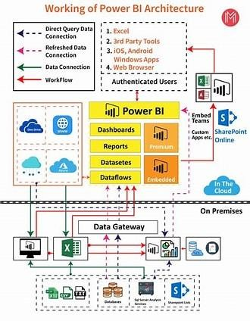

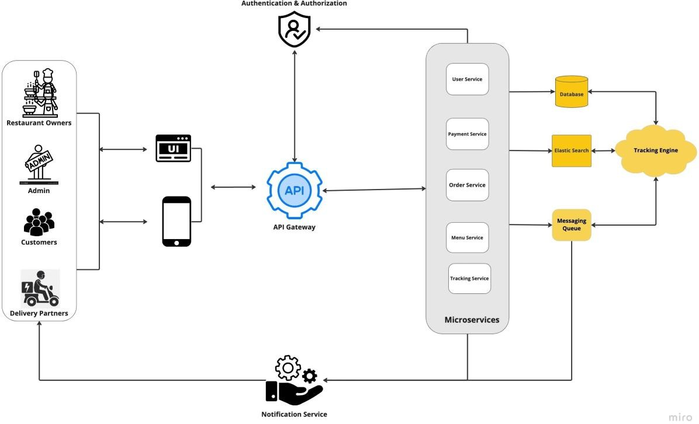

Here's a high-level architecture for an online delivery app:

1. Client-Side (Frontend): User Interface (UI): Developed using HTML, CSS, and JavaScript for web applications, or native UI components for mobile apps. BusinessLogic: Implemented using frontend frameworks like React.js, Angular, or Vue.js to manage user interactions and client-side state. Communication: Interacts with the backend server via RESTful APIs or GraphQL to fetch data, submit orders, and receive updates.
2. Server-Side (Backend): Application Layer: Built using backend technologies such as Node.js, Python (with Django or Flask), Ruby (with Ruby on Rails), or Java (with Spring Boot) to handle business logic, process requests, and manage data. API Endpoints: Exposes RESTful or GraphQL APIs to allow communication between the client-side and server-side components. These endpoints handle requests for user authentication, order management, product catalog, and other functionalities.
3. Authentication and Authorization: Implements user authentication

using mechanisms like JSON Web Tokens (JWT), OAuth, or session-based authentication. Authorizes access to resources based on user roles and permissions.

1. Database: Data Storage: Utilizes a relational database management system (RDBMS) like PostgreSQL, MySQL, or SQLite, or a NoSQL database like MongoDB or Firebase Realtime Database to store user data, product information, orders, and other application data. Data Models: Defines data models and schemas to structure and organize data within the database, ensuring consistency and integrity.
2. External Services: Payment Gateway: Integrates with payment gateways such asStripe, PayPal, or Square to securely process payments for orders. Geolocation Service: Integrates with mapping and geolocation APIs like Google Maps or Mapbox to provide address autocomplete, location-based search, and real-time tracking of deliveries. Communication Service: Integrates with communication APIs like Twilio or Send Grid to send notifications, alerts, and updates to users via SMS, email, or push notifications.
3. Infrastructure: Hosting Platform: Deploys the backend server and database on a cloud hosting platform like Amazon Web Services (AWS), Microsoft Azure, Google Cloud Platform (GCP), or Heroku for scalability, reliability, and availability. ContentDelivery Network (CDN): Utilizes a CDN like Cloudflare or Amazon CloudFront to cache static assets and deliver content efficiently to users worldwide, reducing latency and improving performance.
4. Monitoring and Analytics: Logging and Monitoring: Implements logging and monitoring using tools like Sentry, Loggly, or AWS CloudWatch to track application performance, monitor errors, and troubleshoot issues in real-time.

Analytics: Integrates analytics tools like Google Analytics, Mixpanel, or Firebase Analytics to track user behavior, analyze app usage patterns, and gather insights for optimization and decision-making.

This high-level architecture provides a foundation for building an online delivery app that is scalable, secure, and capable of delivering a seamless user experience across web and mobile platforms.

## CHAPTER 4 MODELING AND RESULT

### Manage relationship

Managing relationships effectively involves cultivating mutual respect, communication, and trust. By actively listening to each other's needs and concerns, addressing conflicts constructively, and demonstrating empathy and understanding, strong relationships can be built and maintained. Regular communication, both verbal and non-verbal, fosters openness and transparency.

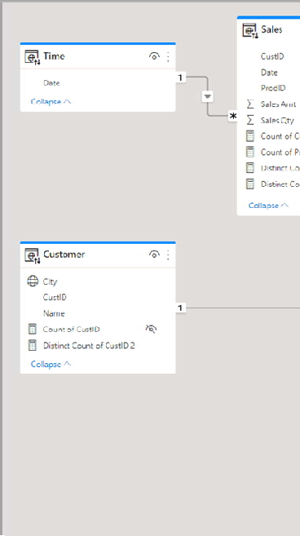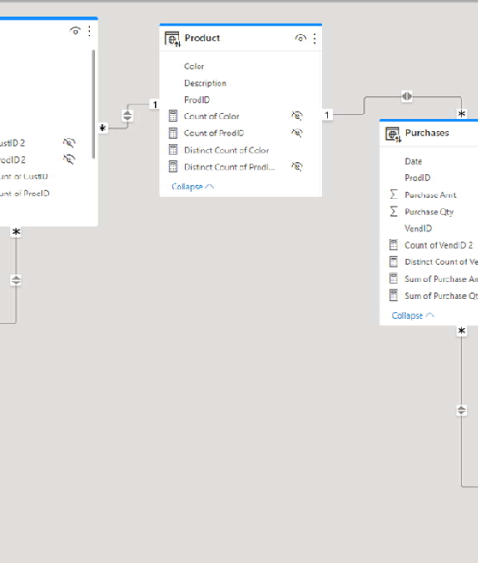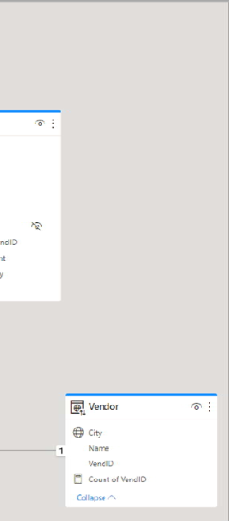

### Edit relationship

Select tables and columns that are related

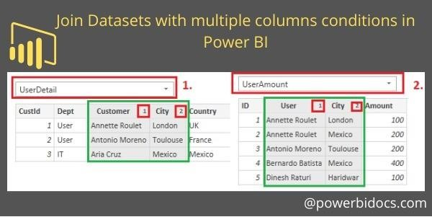

### Dashboard

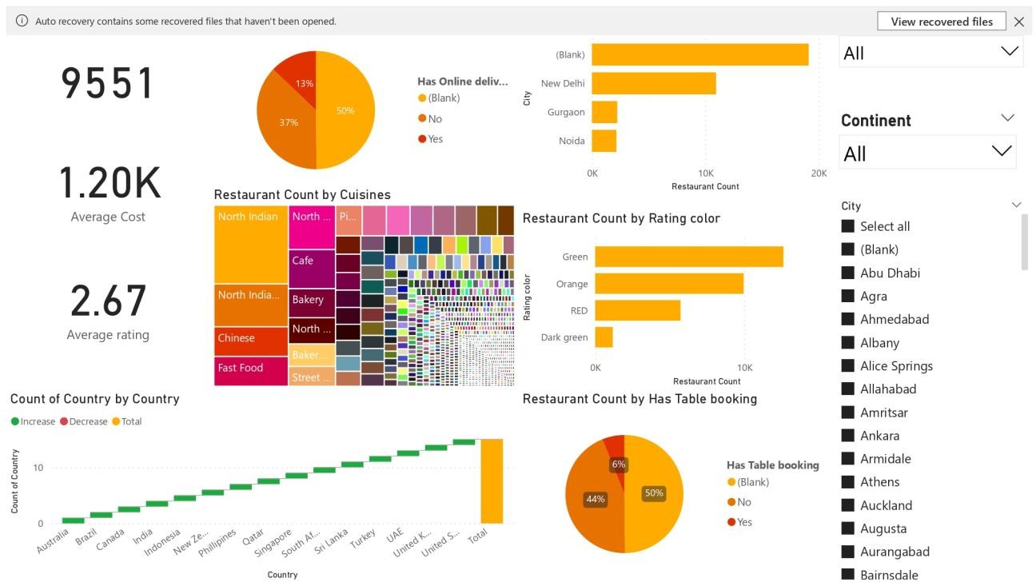

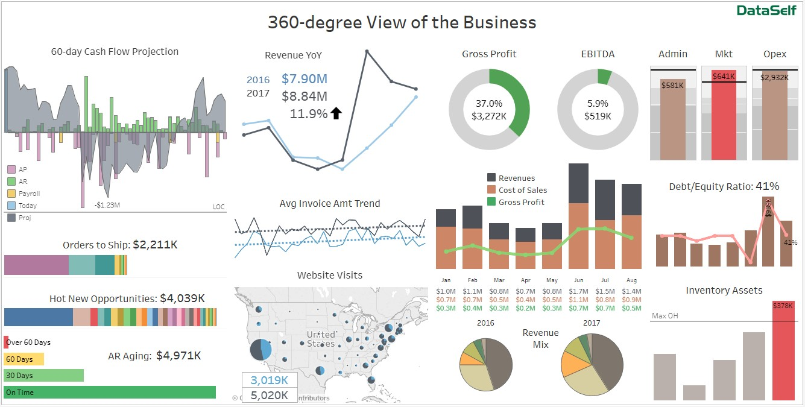

 

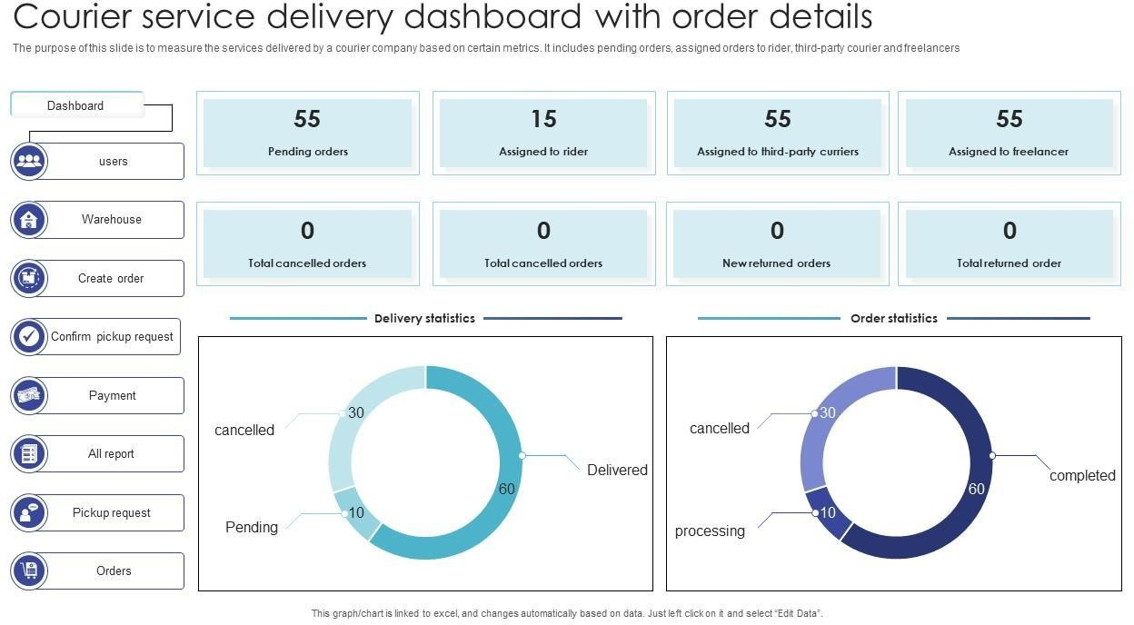

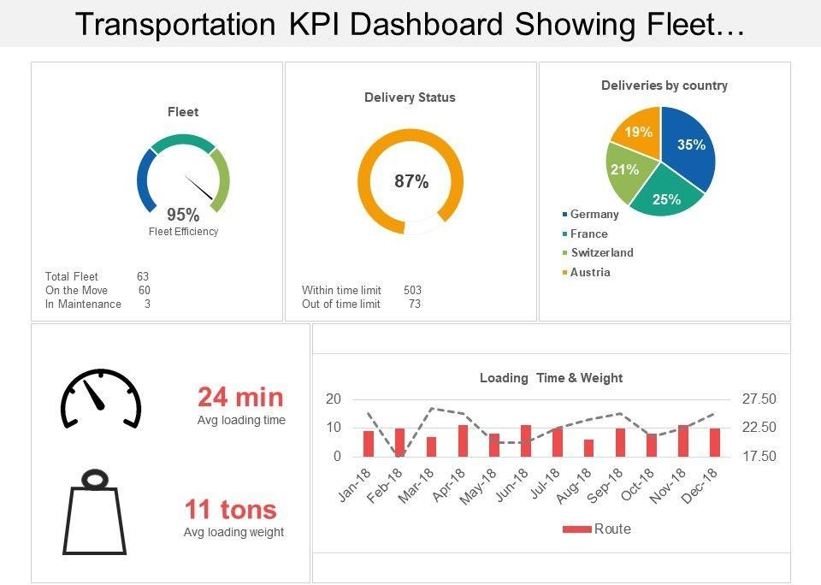

   

## Conclusion

A 360-degree online delivery app offers comprehensive solutions, integrating user-friendly interfaces, efficient order management, diverse payment options, real-time tracking, and seamless communication channels. This holistic approach ensures a streamlined experience for both customers and businesses, ultimately enhancing convenience, reliability, and satisfaction in the online delivery ecosystem.

In the realm of modern convenience, 360-degree online delivery apps stand as pillars of efficiency, revolutionizing the way we procure goods and services.

Through a holistic approach, these platforms have seamlessly integrated a myriad of features, encompassing user-friendly interfaces, robust order management systems, diverse payment options, real-time tracking functionalities, and responsive communication channels.

At the heart of this innovation lies the commitment to enhancing the customer experience. By providing intuitive interfaces, users can effortlessly navigate through a plethora of options, making informed decisions with ease. The inclusion of comprehensive order management systems ensures that every transaction is processed efficiently, minimizing errors and delays.

Moreover, the array of payment options caters to diverse preferences, accommodating various financial situations and preferences. Whether it's traditional methods like credit cards or cutting-edge solutions like mobile wallets, these apps prioritize accessibility and flexibility.

Real-time tracking capabilities further elevate the user experience, offering transparency and peace of mind. Customers can monitor their orders every step of the way, from preparation to delivery, fostering trust and reliability in the platform.

Communication channels serve as lifelines between users and service providers, enabling seamless interaction and swift resolution of any queries or concerns.

Whether it's a change in order status or a special request, the lines of communication remain open, ensuring that every customer feels heard and valued.

In essence, 360-degree online delivery apps represent a convergence of innovation and convenience, redefining the landscape of e-commerce. By prioritizing user

   

experience, efficiency, and reliability, these platforms have become indispensable tools in the modern world, shaping the way we shop, dine, and live. As technology continues to evolve, so too will these apps, continually pushing the boundaries of possibility and setting new standards for excellence in online delivery services.

### FUTURE SCOPE

The future scope for 360-degree online delivery apps is expansive, promising continued evolution and innovation to meet the ever-changing demands of consumers and businesses alike. Here are some potential avenues for growth and development:

1. **\*Enhanced Personalization*:** By leveraging data analytics and machine learning algorithms, delivery apps can tailor recommendations and promotions to individual preferences, providing a more personalized shopping experience.
2. **\*Integration of Emerging Technologies*:** Technologies like augmented reality (AR) and virtual reality (VR) could be integrated into these apps to offer immersive shopping experiences, allowing customers to visualize products in their own space before making a purchase.
3. **\*Expansion into New Markets*:** As online shopping continues to gain traction globally, there's ample opportunity for 360-degree delivery apps to expand into new geographical markets, catering to diverse consumer needs and preferences.
4. **\*Sustainability Initiatives*:** With growing concerns about environmental sustainability, delivery apps can implement eco-friendly practices such as optimizing delivery routes, reducing packaging waste, and partnering with sustainable suppliers.
5. **\*Incorporation of Contactless Delivery*:** In response to the COVID-19 pandemic, contactless delivery options have become increasingly popular. In the future, delivery apps may further refine and expand contactless delivery methods to prioritize safety and convenience.
6. **\*Integration with Smart Devices*:** Seamless integration with smart home devices and IoT (Internet of Things) technology could enable voice-activated ordering, automatic restocking of frequently purchased items, and other innovative features to simplify the shopping process.
7. **\*Expansion Beyond Traditional Goods*:** While most delivery apps currently focus on food and grocery delivery, there's potential for expansion into other

   

verticals such as pharmaceuticals, electronics, and even services like healthcare or home maintenance.

1. **\*Partnerships and Collaborations*:** Collaborations with other businesses, such as restaurants, retailers, and logistics companies, can facilitate the expansion of delivery app services and enhance the overall customer experience.
2. **\*Focus on Last-Mile Delivery Efficiency*:** Last-mile delivery remains a critical challenge for online delivery services. Future advancements in logistics technology, such as drone delivery and autonomous vehicles, could significantly improve efficiency and reduce delivery times.
3. **\*Subscription-based Models*:** Introducing subscription-based models for frequent users could provide added value and convenience, offering benefits such as discounted delivery fees, exclusive deals, and priority service.

Overall, the future for 360-degree online delivery apps is brimming with potential, driven by technological advancements, shifting consumer preferences, and the ongoing quest for convenience and efficiency in the digital age.

# REFERENCES

https://powerbi.pl/en/ms-power-bi/360-degree-analytics

   

# LINK

<https://github.com/Nivetha140/ONLINE-DELIVERY-APPS_NM-ID_76BB59C7042CB7689B0488C53ADAC317>